# First Name: Last Name:

In [1]:

**import** pandas **as** pd **import** numpy **as** np **import** seaborn **as** sns

**import** statsmodels.formula.api **as** smf **import** statsmodels.stats.multicomp **as** multi **import** matplotlib.pyplot **as** plt

# From Prac 1 to 3

In [2]:

nesarc = pd.read_csv('nesarc.csv', low_memory=**False**) pd.set_option('display.float_format', **lambda** x:'%f'**%**x)

In [3]:

nesarc['S2AQ5B'] = pd.to_numeric(nesarc['S2AQ5B'], errors='coerce') *#convert variable to nu* nesarc['S2AQ5D'] = pd.to_numeric(nesarc['S2AQ5D'], errors='coerce') *#convert variable to nu* nesarc['S2AQ5A'] = pd.to_numeric(nesarc['S2AQ5A'], errors='coerce') *#convert variable to nu*

In [4]:

sub1=nesarc[(nesarc['AGE']**>**=26) **&** (nesarc['AGE']**<**=50) **&** (nesarc['S2AQ5A']==1)] sub2=sub1.copy()

In [5]:

*#SETTING MISSING DATA*

sub2['S2AQ5D']=sub2['S2AQ5D'].replace(99, np.nan)

sub2['S2AQ5B']=sub2['S2AQ5B'].replace(8, np.nan) sub2['S2AQ5B']=sub2['S2AQ5B'].replace(9, np.nan) sub2['S2AQ5B']=sub2['S2AQ5B'].replace(10, np.nan) sub2['S2AQ5B']=sub2['S2AQ5B'].replace(99, np.nan)

In [6]:

recode2 = {1:30, 2:26, 3:14, 4:8, 5:4, 6:2.5, 7:1}

sub2['BEER_FEQMO']= sub2['S2AQ5B'].map(recode2) sub2['BEER_FEQMO']= pd.to_numeric(sub2['BEER_FEQMO'])

*# Creating a secondary variable multiplying the days consumed beer/month and the number of* sub2['NUMBEERMO_EST']=sub2['BEER_FEQMO'] **\*** sub2['S2AQ5D']

sub2['NUMBEERMO_EST']= pd.to_numeric(sub2['NUMBEERMO_EST'])

In [8]:

ct1 = sub2.groupby('NUMBEERMO_EST').size() print (ct1)

|  |  |
| --- | --- |
| NUMBEERMO_EST |  |
| 1.000000 | 477 |
| 2.000000 | 407 |
| 2.500000 | 414 |
| 3.000000 | 172 |
| 4.000000 | 429 |
| 5.000000 | 623 |
| 6.000000 | 36 |
| 7.000000 | 5 |
| 7.500000 | 267 |
| 8.000000 | 635 |
| 10.000000 | 119 |
| 12.000000 | 296 |
| 12.500000 | 48 |
| 14.000000 | 160 |
| 15.000000 | 87 |
| 16.000000 | 561 |
| 17.500000 | 5 |
| 18.000000 | 1 |
| 20.000000 | 81 |
| 22.500000 | 3 |
| 24.000000 | 410 |
| 25.000000 | 6 |
| 26.000000 | 51 |
| 27.500000 | 1 |
| 28.000000 | 242 |
| 30.000000 | 62 |
| 32.000000 | 168 |
| 35.000000 | 1 |
| 36.000000 | 3 |
| 37.500000 | 2 |
| ... | |
| 98.000000 | 9 |
| 104.000000 | 37 |
| 112.000000 | 21 |
| 120.000000 | 39 |
| 130.000000 | 13 |
| 140.000000 | 5 |
| 144.000000 | 2 |
| 150.000000 | 18 |
| 156.000000 | 54 |
| 168.000000 | 27 |
| 180.000000 | 77 |
| 182.000000 | 6 |
| 192.000000 | 3 |
| 208.000000 | 10 |
| 210.000000 | 5 |
| 234.000000 | 2 |
| 240.000000 | 13 |
| 252.000000 | 5 |
| 260.000000 | 3 |
| 270.000000 | 4 |
| 300.000000 | 6 |
| 312.000000 | 14 |
| 360.000000 | 25 |
| 468.000000 | 1 |

|  |  |
| --- | --- |
| 510.000000 | 1 |
| 520.000000 | 1 |
| 540.000000 | 2 |
| 624.000000 | 1 |
| 720.000000 | 2 |
| 900.000000 | 1 |
| Length: 75, | dtype: int64 |

# Categorical -> Quantitative - ANOVA

In [9]:

sub2['DYSLIFE'] = sub2['DYSLIFE'].astype('category')

# Draw boxplot to show relationship between minor depression status (DYSLIFE (categorical)) and estimated number of beer consumed (NUMBEERMO_EST (quantitative))

**%**matplotlib notebook

sns.boxplot(x='DYSLIFE', y='NUMBEERMO_EST', data=sub2) plt.xlabel('DYSLIFE')

plt.ylabel('NUMBEERMO_EST')

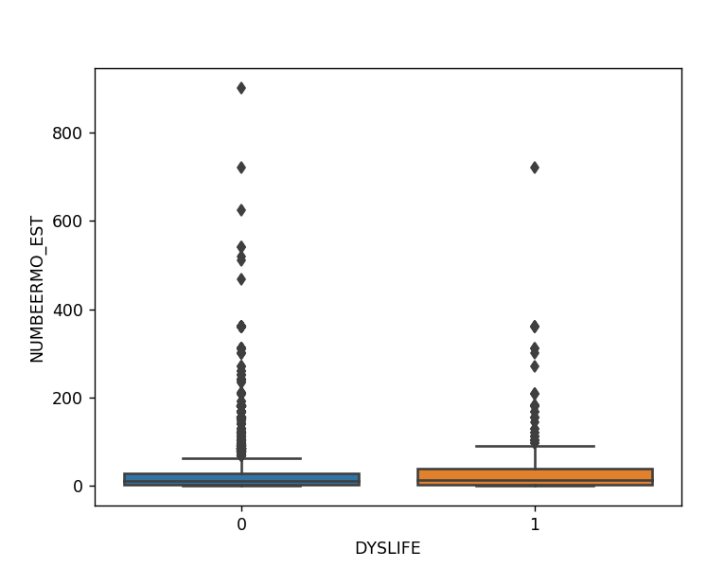

**Figure 1**

Out[22]: Text(0,0.5,'NUMBEERMO_EST')

# Perform ANOVA analysis between minor depression status (DYSLIFE (categorical)) and estimated number of beer consumed (NUMBEERMO_EST (quantitative))

In [11]:

model1 = smf.ols(formula='NUMBEERMO_EST ~ C(DYSLIFE)', data=sub2).fit() print (model1.summary())

OLS Regression Results

============================================================================

==

|  |  |  |  |
| --- | --- | --- | --- |
| Dep. Variable: | NUMBEERMO_EST | R-squared: | 0.0 |
| 03 |  |  |  |
| Model: | OLS | Adj. R-squared: | 0.0 |
| 03 |  |  |  |
| Method: | Least Squares | F-statistic: | 20. |
| 23 |  |  |  |
| Date: | Fri, 27 Apr 2018 | Prob (F-statistic): | 6.99e- |
| 06 |  |  |  |
| Time: | 14:58:59 | Log-Likelihood: | -3880 |
| 4. |  |  |  |
| No. Observations: | 7303 | AIC: | 7.761e+ |
| 04 |  |  |  |
| Df Residuals: | 7301 | BIC: | 7.763e+ |
| 04 |  |  |  |
| Df Model:  Covariance Type: | 1  nonrobust |  |  |

============================================================================

=======

|  |  |  |  |  |  |
| --- | --- | --- | --- | --- | --- |
| 0.975] | coef | std err | t | P>|t| | [0.025 |
|  |  |  |  |  |  |
| Intercept | 27.2277 | 0.587 | 46.361 | 0.000 | 26.076 |
| 28.379 |  |  |  |  |  |
| C(DYSLIFE)[T.1] | 12.9670 | 2.883 | 4.497 | 0.000 | 7.315 |
| 18.619 |  |  |  |  |  |
| ============================================================================  == | | | | | |
| Omnibus: | 7622.371 | | Durbin-Watson: | | 2.0 |
| 26 |  | |  | |  |
| Prob(Omnibus): | 0.000 | | Jarque-Bera (JB): | | 640965.7 |
| 69 |  | |  | |  |
| Skew: | 5.150 | | Prob(JB): | | 0. |
| 00 |  | |  | |  |
| Kurtosis: | 47.725 | | Cond. No. | | 5. |
| 02 |  | |  | |  |
| ============================================================================  == | | | | | |

Warnings:

[1] Standard Errors assume that the covariance matrix of the errors is corre ctly specified.

In [12]:

sub3 = sub2[['NUMBEERMO_EST', 'DYSLIFE']].dropna()

# print the mean of number of beer consumed grouped

**by minor depression status**

In [13]:

print ('means for NUMBEERMO_EST by minor depression status') m1= sub3.groupby('DYSLIFE').mean()

print (m1)

means for NUMBEERMO_EST by minor depression status NUMBEERMO_EST

DYSLIFE

0 27.227714

1 40.194719

# print the standard deviation (std) of number beer consumed grouped by minor depression status

In [14]:

print ('standard deviations for NUMBEERMO_EST by minor depression status') sd1 = sub3.groupby('DYSLIFE').std()

print (sd1)

standard deviations for NUMBEERMO_EST by minor depression status NUMBEERMO_EST

DYSLIFE

0 47.678467

1 75.407118

# Categorical (>2) -> Quantitative - ANOVA

In [15]:

sub2['ETHRACE2A'] = sub2['ETHRACE2A'].astype('category') sub2['ETHRACE2A']=sub2['ETHRACE2A'].cat.rename_categories(["White", "Black", "NatAm", "Asia

# Draw boxplot to show relationship between ethinicity (ETHRACE2A (categorical)) and estimated number of beer consumed (NUMBEERMO_EST (quantitative))

**%**matplotlib notebook

sns.boxplot(x='ETHRACE2A', y='NUMBEERMO_EST', data=sub2) plt.xlabel('ETHRACE2A')

plt.ylabel('NUMCIGMO_EST')

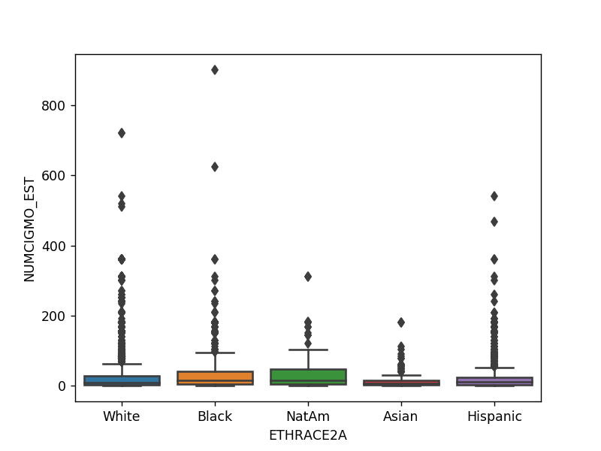

Out[16]: Text(0,0.5,'NUMCIGMO_EST')

In [17]:

sub4 = sub2[['NUMBEERMO_EST', 'ETHRACE2A']].dropna()

# Perform ANOVA analysis between ethinicity (ETHRACE2A (categorical)) and estimated number of beer consumed (NUMBEERMO_EST (quantitative))

In [18]:

model2 = smf.ols(formula='NUMBEERMO_EST ~ C(ETHRACE2A)', data=sub4).fit() print (model2.summary())

OLS Regression Results

============================================================================

==

|  |  |  |  |
| --- | --- | --- | --- |
| Dep. Variable: | NUMBEERMO_EST | R-squared: | 0.0 |
| 05 |  |  |  |
| Model: | OLS | Adj. R-squared: | 0.0 |
| 04 |  |  |  |
| Method: | Least Squares | F-statistic: | 8.2 |
| 61 |  |  |  |
| Date: | Fri, 27 Apr 2018 | Prob (F-statistic): | 1.21e- |
| 06 |  |  |  |
| Time: | 14:59:00 | Log-Likelihood: | -3879 |
| 7. |  |  |  |
| No. Observations: | 7303 | AIC: | 7.760e+ |
| 04 |  |  |  |
| Df Residuals: | 7298 | BIC: | 7.764e+ |
| 04 |  |  |  |
| Df Model:  Covariance Type: | 4  nonrobust |  |  |

============================================================================

================

coef std err t P>|t|

[0.025 0.975]

|  |  |  |  |  |  |  |
| --- | --- | --- | --- | --- | --- | --- |
| Intercept |  | 27.8589 | 0.742 | 37.535 | 0.000 | 2 |
| 6.404 | 29.314 |  |  |  |  |  |
| C(ETHRACE2A)[T.Black] | | 4.5843 | 1.656 | 2.768 | 0.006 |  |
| 1.338 7.831 | |  |  |  |  |  |
| C(ETHRACE2A)[T.NatAm] | | 11.6496 | 4.581 | 2.543 | 0.011 |  |
| 2.670 20.629 | |  |  |  |  |  |
| C(ETHRACE2A)[T.Asian] | | -11.2589 | 3.594 | -3.133 | 0.002 | -1 |
| 8.304 -4.214 | |  |  |  |  |  |
| C(ETHRACE2A)[T.Hispanic] | | -3.2403 | 1.464 | -2.213 | 0.027 | - |
| 6.111 -0.370 | |  |  |  |  |  |

============================================================================

==

|  |  |  |  |
| --- | --- | --- | --- |
| Omnibus: | 7639.304 | Durbin-Watson: | 2.0 |
| 27 |  |  |  |
| Prob(Omnibus): | 0.000 | Jarque-Bera (JB): | 646522.8 |
| 33 |  |  |  |
| Skew: | 5.167 | Prob(JB): | 0. |
| 00 |  |  |  |
| Kurtosis: | 47.921 | Cond. No. | 8. |
| 28 |  |  |  |

============================================================================

==

Warnings:

[1] Standard Errors assume that the covariance matrix of the errors is corre ctly specified.

# print the mean of number of beer consumed grouped by ethinicity

In [19]:

print ('means for NUMBEERMO_EST by ethinicity') m2= sub4.groupby('ETHRACE2A').mean()

print (m2)

|  |  |
| --- | --- |
| means for | NUMBEERMO_EST by ethinicity |
|  | NUMBEERMO_EST |
| ETHRACE2A |  |
| White | 27.858922 |
| Black | 32.443182 |
| NatAm | 39.508475 |
| Asian | 16.600000 |
| Hispanic | 24.618638 |

# print the standard deviation (std) of number of beer consumed grouped by ethinicity

In [20]:

print ('standard deviations for NUMBEERMO_EST by ethnicity') sd2 = sub4.groupby('ETHRACE2A').std()

print (sd2)

standard deviations for NUMBEERMO_EST by ethnicity NUMBEERMO_EST

ETHRACE2A

|  |  |
| --- | --- |
| White | 50.537013 |
| Black | 55.289755 |
| NatAm | 57.231386 |
| Asian | 25.572698 |
| Hispanic | 41.073842 |

# Perform Tukey’s Honestly Significant Difference (Post hoc) test

In [21]:

mc1 = multi.MultiComparison(sub4['NUMBEERMO_EST'], sub4['ETHRACE2A']) res1 = mc1.tukeyhsd()

print(res1.summary())

Multiple Comparison of Means - Tukey HSD,FWER=0.05

==================================================

|  |  |  |  |  |  |
| --- | --- | --- | --- | --- | --- |
| group1 | group2 | meandiff | lower | upper | reject |
| Asian | Black | 15.8432 | 5.4332 | 26.2532 | True |
| Asian | Hispanic | 8.0186 | -2.1752 | 18.2124 | False |
| Asian | NatAm | 22.9085 | 7.2827 | 38.5343 | True |
| Asian | White | 11.2589 | 1.4533 | 21.0646 | True |
| Black | Hispanic | -7.8245 | -13.1332 | -2.5159 | True |
| Black | NatAm | 7.0653 | -5.9129 | 20.0435 | False |
| Black | White | -4.5843 | -9.103 | -0.0655 | True |
| Hispanic | NatAm | 14.8898 | 2.0844 | 27.6953 | True |
| Hispanic | White | 3.2403 | -0.7553 | 7.2359 | False |
| NatAm | White | -11.6496 | -24.1482 | 0.8491 | False |